SPRINT-4

TEAM ID: PNT2022TMID12310

PROJECT NAME : IoT based smart crop protection system for Agriculture

Step1:MIT APP inventor to design the APP

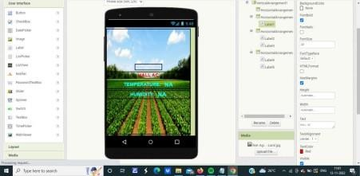

Step2:Customize the APP interface to display the values

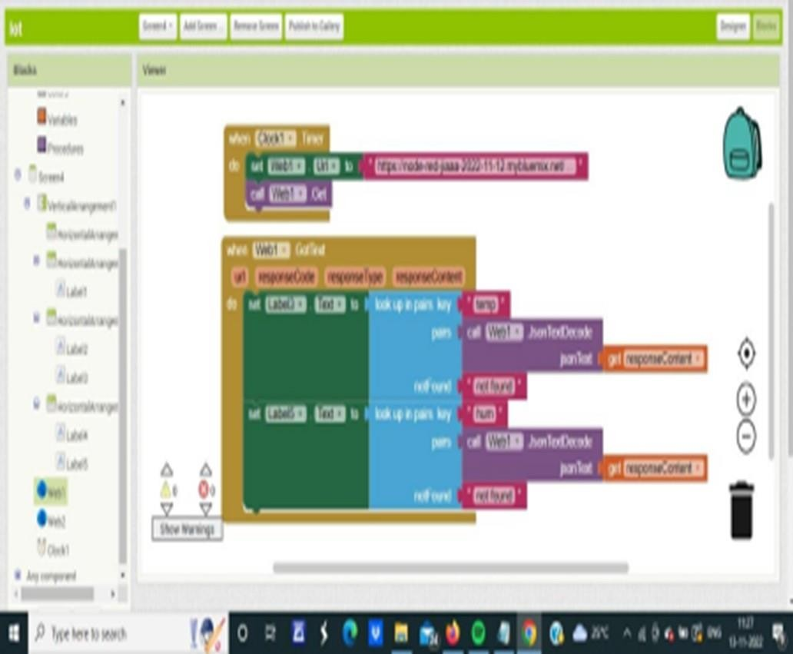

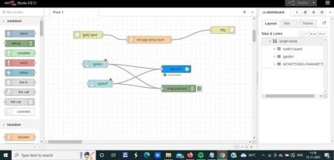

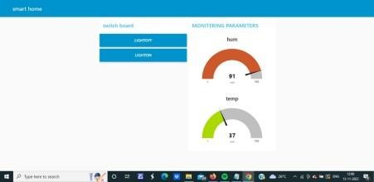

Step1:MIT APP inventor to design the APP

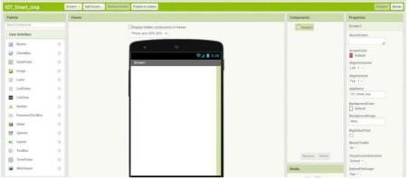

Step2:Customize the APP interface to display the values

